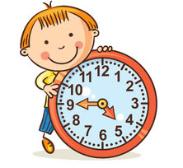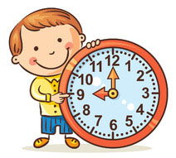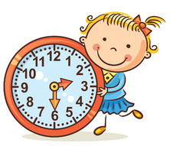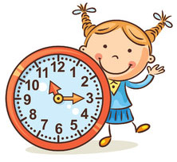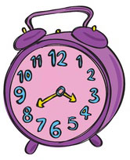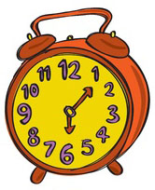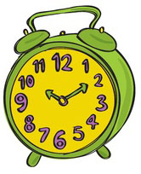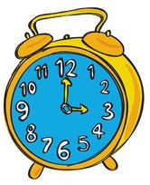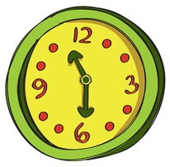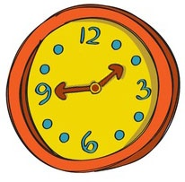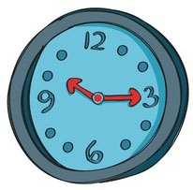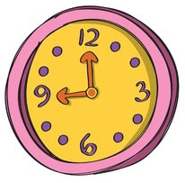red.jpg

7. Say the hours:

6. Click to listen and choose

True / false True / false

to

It’s

twenty

five

four

six

past

5. Drag and drop

It’s

4. Join with arrows

It’s a quarter to seven  
It’s half past nine  
It’s twenty to six  
It’s ten past ten  
It’s eleven o’clock  
It’s two to two

23:00  
13:58  
06:45  
21:30  
17:40  
22:10

It’s half past three.  
It’s half past twelve.  
It’s twelve o’clock.  
It’s three o’clock.

It’s ten to ten.  
It’s ten past ten.  
It’s half past ten.  
It’s ten o’clock.

3. Choose the right answer

2. Choose the right answer

1. What time is it?

**THE HOURS**